
TOPIC: Introduction to Database Systems
Student Name: Aljesh Basnet
Student Id: NP03S190047
Submitted date: April 5, 2019
Submitted to: Chiranjivi Khanal
Word Count: 1051

Acknowledgement

The making of the report needed co-operation and guidance of a number of people. I therefore consider it my prime duty to thank all those who had helped me for making it successful. It is my immense pleasure to express my gratitude to Mr. Chiranjivi khanal (Module Teacher of Introduction to Database Systems) as a guide who provided me constructive and positive feedback during the preparation of this report. Last but not least, I am thankful to my friends and library staff members whose encouragement and suggestion helped me to complete my report. I am also thankful to my parents.

Table of Contents
1
Section A 1
1. Research on three mostly used database 1
1.1. Oracle 1
1.1.1. Features of Oracle 1
1.1.2. Clients of Oracle 1
1.2. MySQL 2
1.2.1. Features of MySQL 2
1.2.2. Clients of MySQL 2
1.3. MS SQL Server 3
1.3.1. Features of MS SQL Server 3
1.3.2. Clients of MS SQL Server 3
2. Attributes of student, Books and Publisher 4
2.1. Student 4
2.2. Books 4
2.3. Publisher 5
Section B 5
3. Relational Model 5
3.1. Identifying Entities and Attributes for given scenario 5
3.1.1. Entities 5
3.1.2. Attributes 6
3.2. Showing and resolving the cardinality of above scenario 6
Section C 7
4. Creating above tables using DBMS 7
10
Section D 10
5. SQL 10
5.1. Inserting 10 records for each table created 10
5.2. Updating the book code ‘B101’ to name ‘Introduction to Database’ 13
5.3. Delete book with code ‘B207’ 14
5.4. Displaying the name of the Books in Alphabet order 15
5.5. Displaying the code, Name and Quantity of books in descending order 16
5.6. Listing the name of Book shaving unit price above 1000 borrowed by reader B204. 17
Conclusion 19
Bibliography 20

Section A

Research on three mostly used database

Oracle

An Oracle database is a class of data treated as a unit. The resolution of this database is to store and retrieve related information. A database server is crucial to solving the queries of information management. Many user can access the same data as a server manages large amount of data in a multiuser environment in a secure process delivering high performance. (Oracle, 2019)

1.1.1. Features of Oracle

- Oracle provides high availability of data and protects the data from data corruption.
- Oracle ensures none separate downloads.
- Oracle provides outstanding performance for transactions using row and column format.
- By changing assumptions around where data inhabit in runtime, Oracle supplies real time application performance (low response time).
- Oracle amplifies data management and availability of large data bases by erasing individual servers of databases as a single point of failure.
- Oracle provides comprehensive set of flattening ability to reduce storage and improve database performance. (Oracle, 2019)

1.1.2. Clients of Oracle

  - Capcom Co., Ltd
  - CAIRN India
  - COOP Switzerland

MySQL

MySQL is easy-to-use, fast RDBMS (Relational Database Management System). It is used for many small as well as big businesses as it is more reliable and cheaper than other databases as MySQL functions on SQL data language. (Kofler, 2019)

1.2.1. Features of MySQL
- MySQL follows a client /server architecture where a database server (MySQL) and randomly many clients (application programs), communicate with each other.
- MySQL functions under many operating systems and with numerous languages including PHP, JAVA, C, C++, etc.
- MySQL is well suited for Geographic Information Systems (GIC) and has supported the storing and processing of two-dimensional geographical data.
- MySQL addresses all the usual programming languages that run under Microsoft Windows as MySQL supports the ODBC interface (A driver which connects MySQL database server through open database connectivity application program interface).
- MySQL executes several databases as a block and fortifies either all of the operation are correctly executed or none of them.
- MySQL software can be changed to fit to the programmer’s environments due to open source GPL license.
- MySQL permits the content of a database to be copied to numerous computers. (Kofler, 2019)

1.2.2. Clients of MySQL

- Facebook
- Wikipedia
- Word Press

MS SQL Server

SQL Server is a Relational Database Management System introduced by Microsoft. It supports ANSI SQL which is standard SQL language which comes with implementation of transact SQL language. Transact-SQL provides capabilities of declaring variable, large storage, exception handling, etc. The main interface tool for SQL server is SQL Server Management System (SSMS) which supports both 32 and 64 bit computers. (Guru99, 2019)

1.3.1. Features of MS SQL Server

- Different versions of SQL Server can be installed in a same machine where each installation works individually from the other installation.
- To run SQL Server, purchasing license is not needed.
- SQL Server reduces temporary database problems as services are run on different instances.
- SQL Server maintains standby server which comes in handy if the current server fails.
- SQL Server provides SQL Server Analysis Services (SSAS) which supplies data mining, data analysis and machine learning capabilities.
- SQL Server provides SQL Server Reporting Services (SSRS) which supplies reporting features and decision making capabilities.
- SQL Server provides SQL Server Integration Services (SSRS) which supplies extraction and loading potential of different type of data from one source to another. (Guru99, 2019)

1.3.2. Clients of MS SQL Server
- University of Utah
- Landmark Health, LLC
- Key sight Technologies, Inc. (iDatalabs, 2019)

Attributes of student, Books and Publisher

Student

Field Name | Data Type | Data Size
Student_ID | Int | 10
Student_Name | Varchar | 20
Address | Varchar | 30
E-Mail | Varchar | 30
Phone | Int | 20

Books

Field Name | Data Type | Data Size
Book_ID | Int | 10
Book_Name | Varchar | 20
ISBN | Int | 15
Author | Varchar | 20
Price | Int | 30
Publisher | Varchar | 20

Publisher

Field name | Data Type | Length
Publisher_ID | Int | 20
Publisher_Name | Varchar | 20
Address | Varchar | 30
E-Mail | Varchar | 30
Phone | Int | 20

Section B

Relational Model

Identifying Entities and Attributes for given scenario

Entities

- Borrowers
- Books
- Borrow

Attributes

Borrowers
Borrower_ID
Borrower_Name
Borrower_ContactNo
Borrower_Address
Borrow
Borrow_ID
Borrow_Date
Borrower_ID
Books_ID
Books
Book_ID
Book_Name
Book_Publisher
Book_Author
Book_Quantity

Showing and resolving the cardinality of above scenario
A reader can borrow a maximum of THREE books at a time:

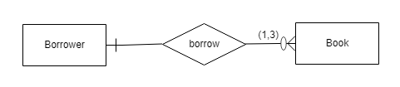

A reader can only issue maximum of 3 books only so the relation here is one-to-many relationship. Here, the borrower may or may not borrow a book and also they might borrow any amount of book below 3.
Hence, their relationship is one-to-many.
Same Book can be borrowed by MANY readers [depends on number of copies]:
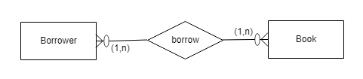

Many borrower can borrow many books (one to three books at a time) and the content of the book might be single or unique but there can be multiple copies of that particular book. Hence, there is many-to many relationship between the reader and books.
ER diagram

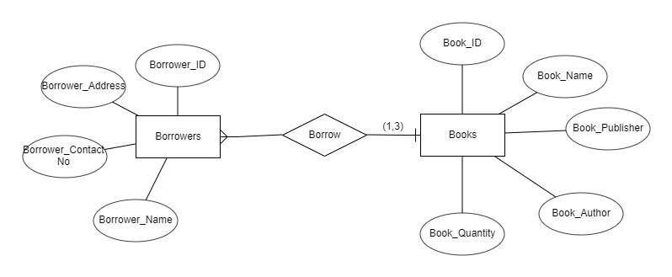

Section C

Creating above tables using DBMS

Creating Database Open_Book_Library

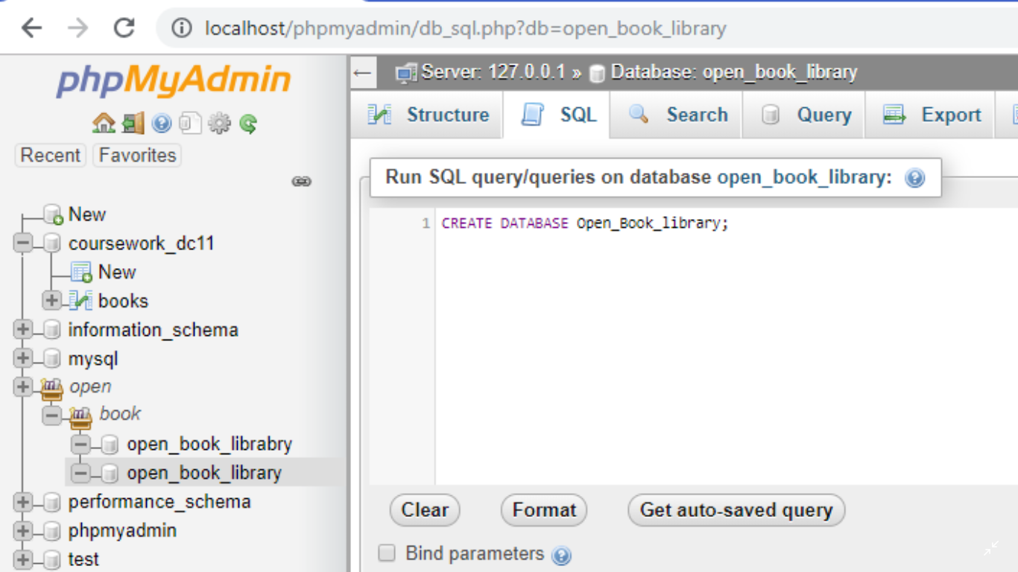

Creating table for Books
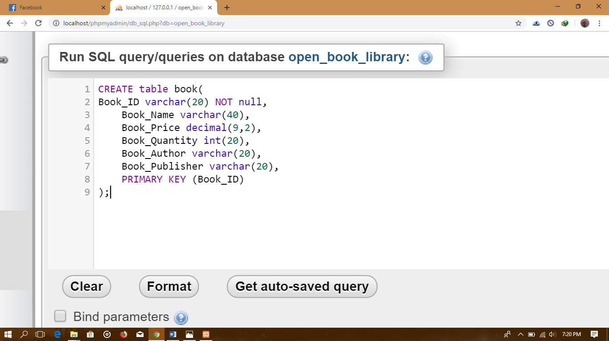

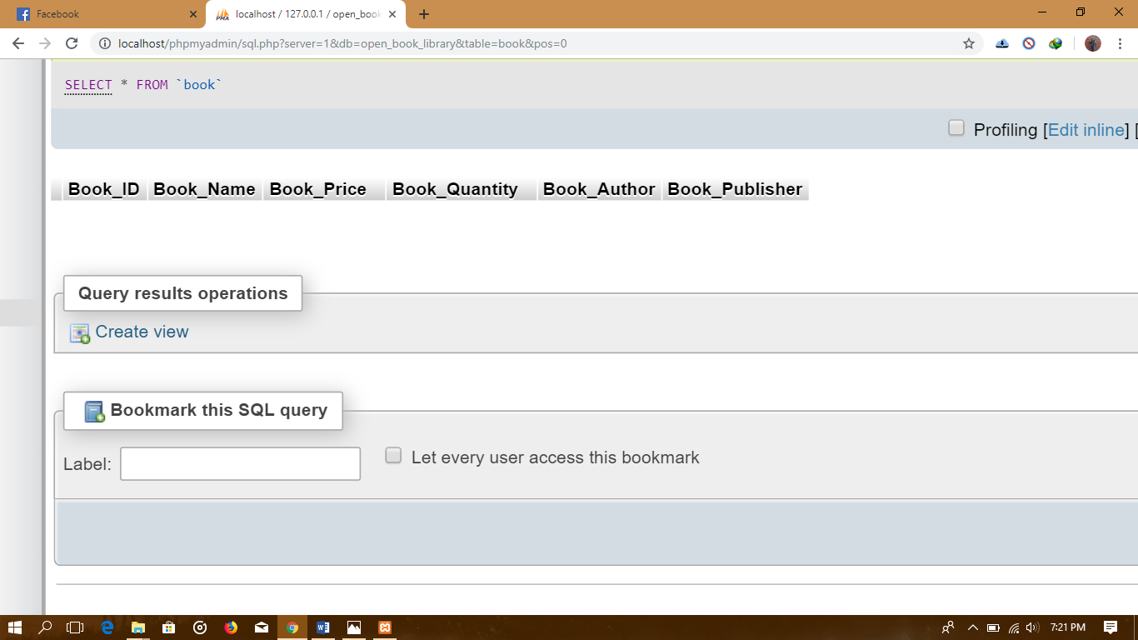

Creating Tables for Borrower
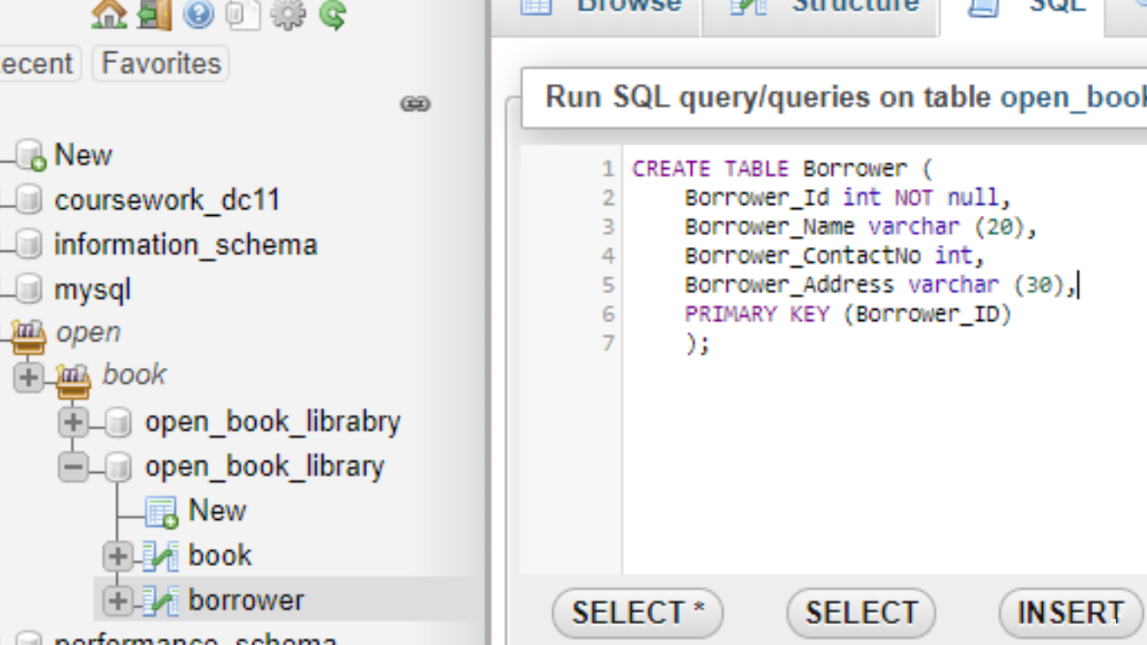

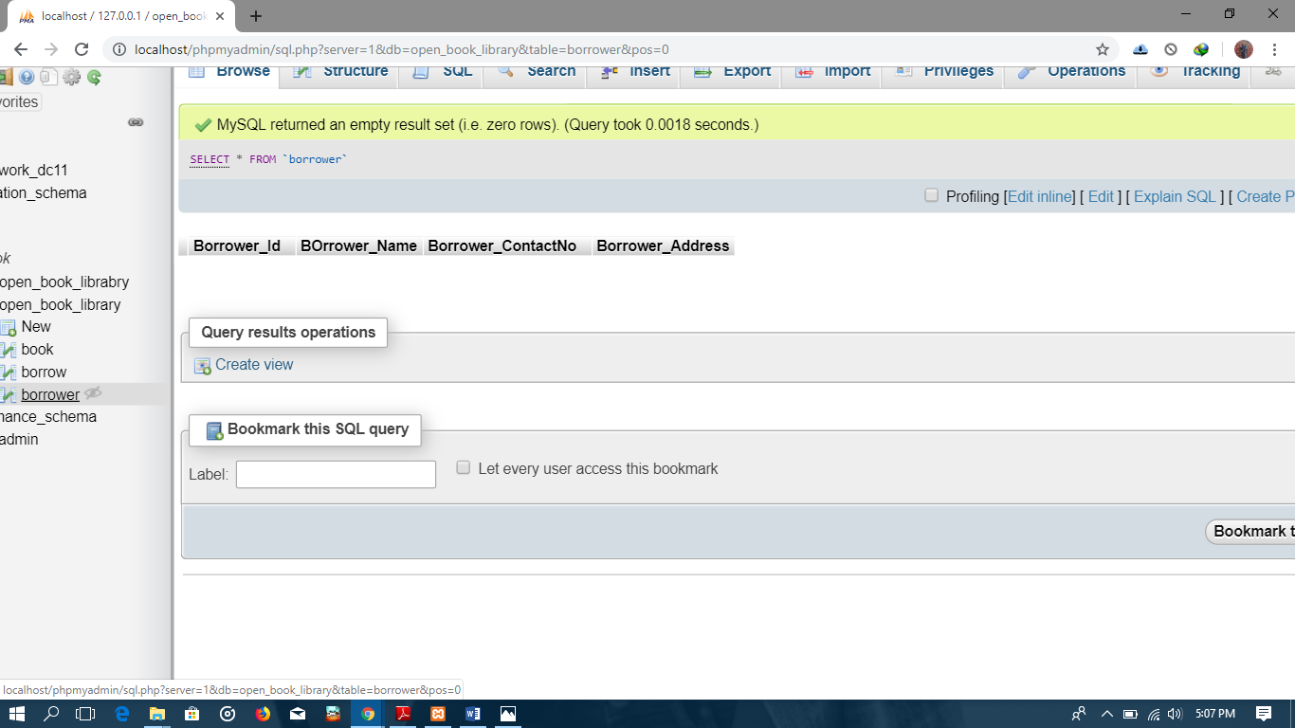

Creating Tables for Borrow
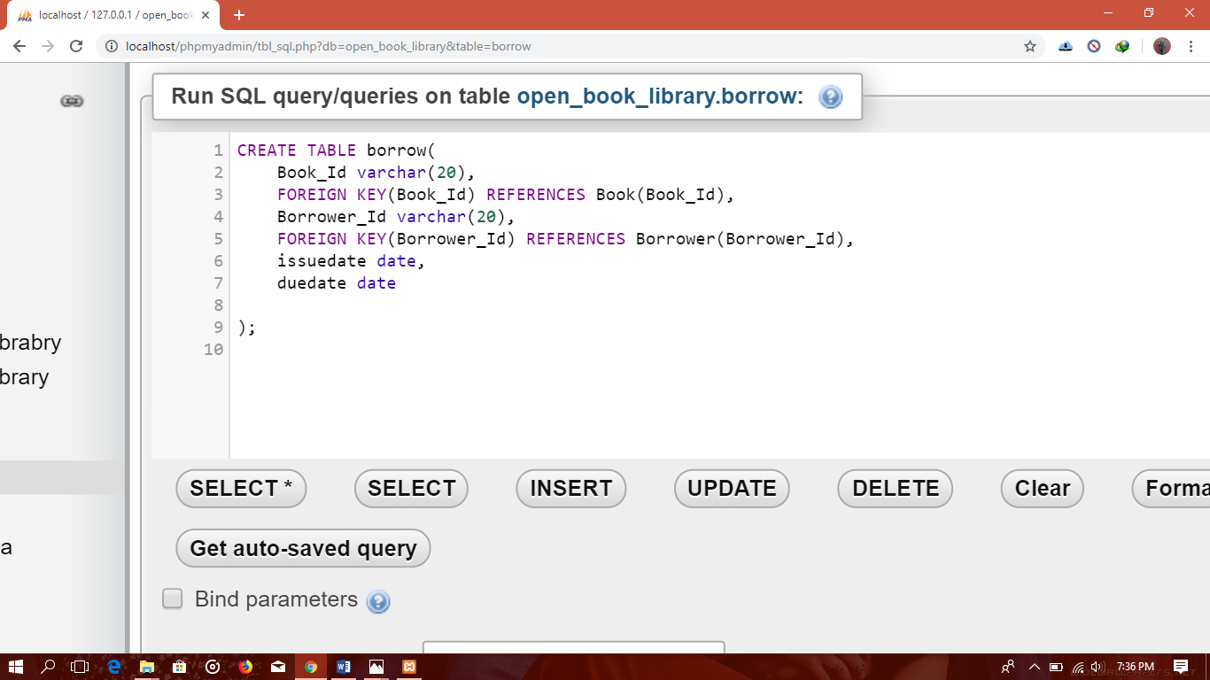

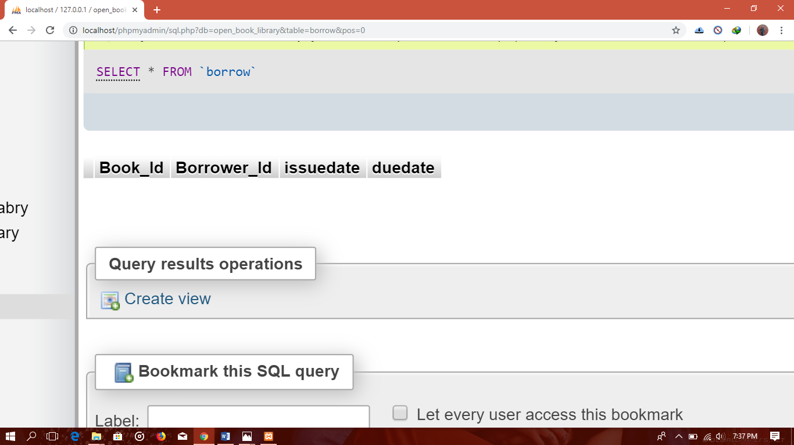

Section D

SQL

Inserting 10 records for each table created
For book
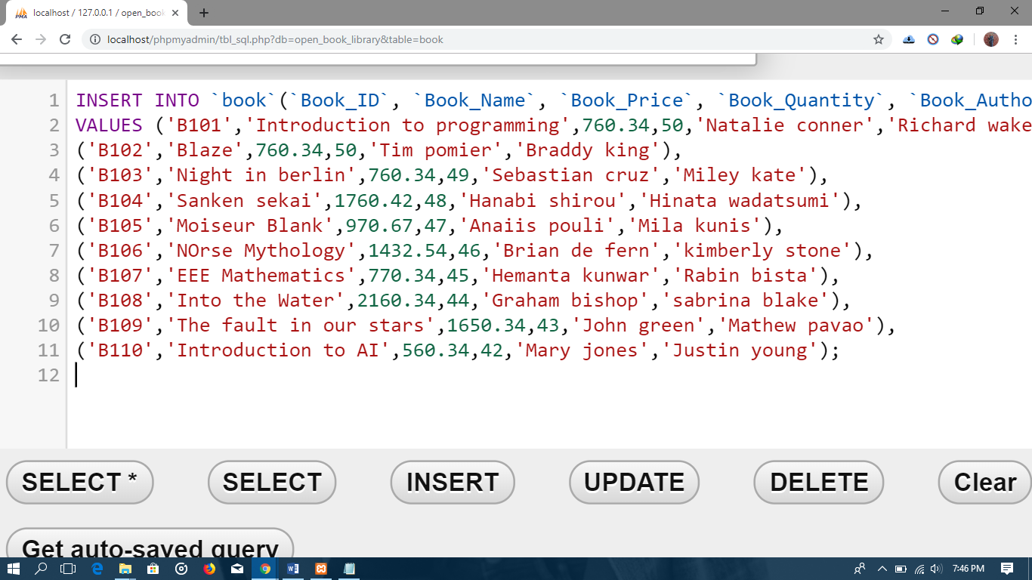

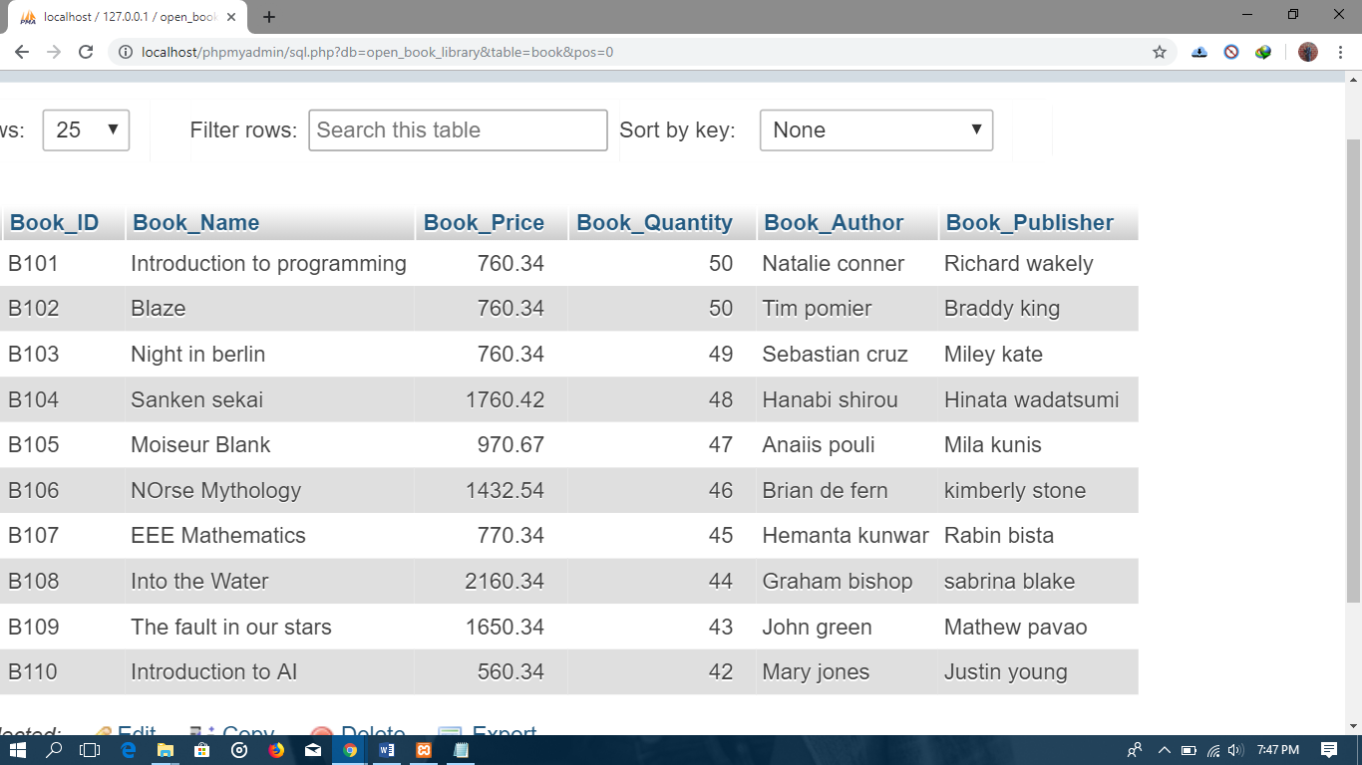

For borrower
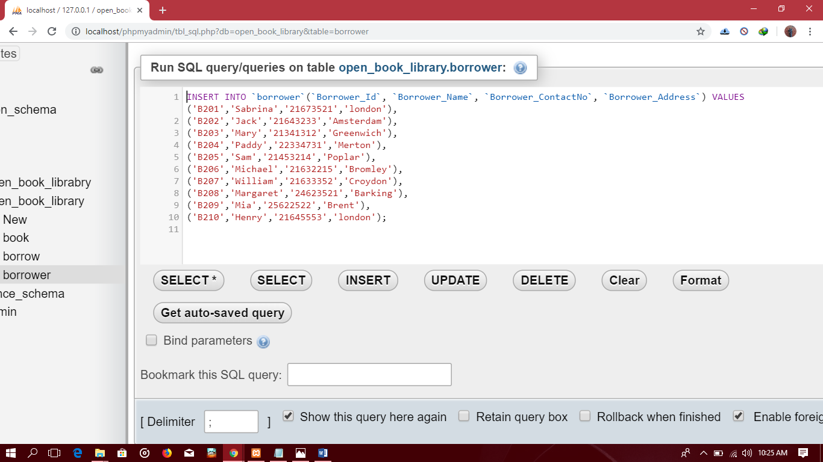

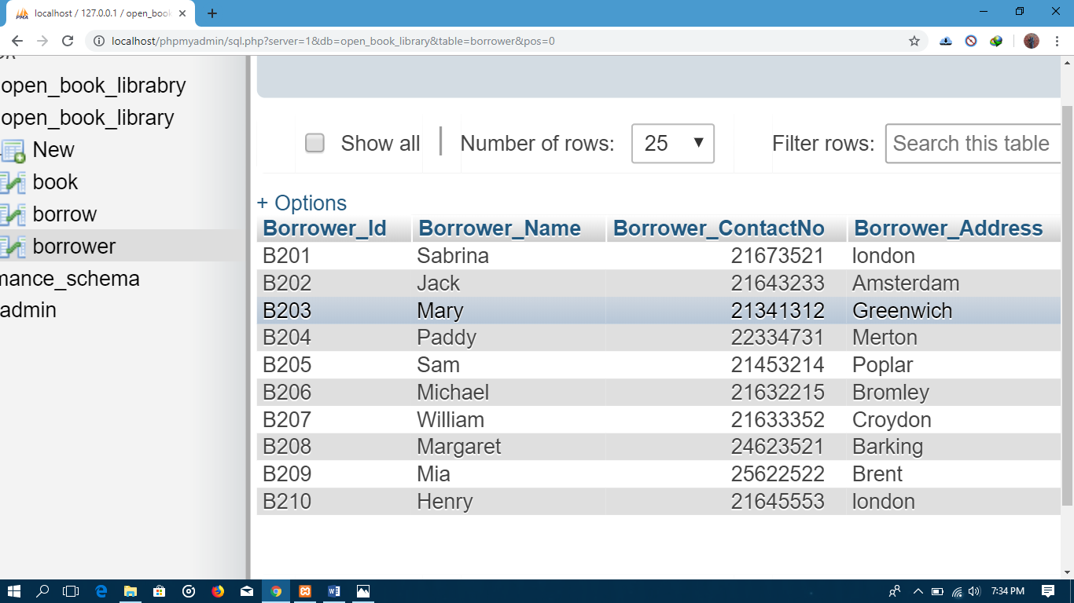

For borrow
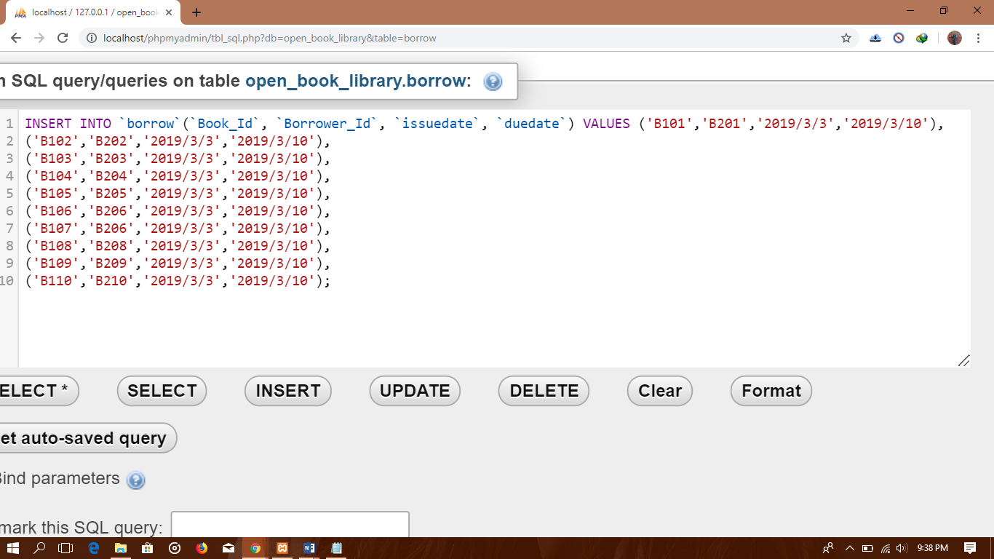

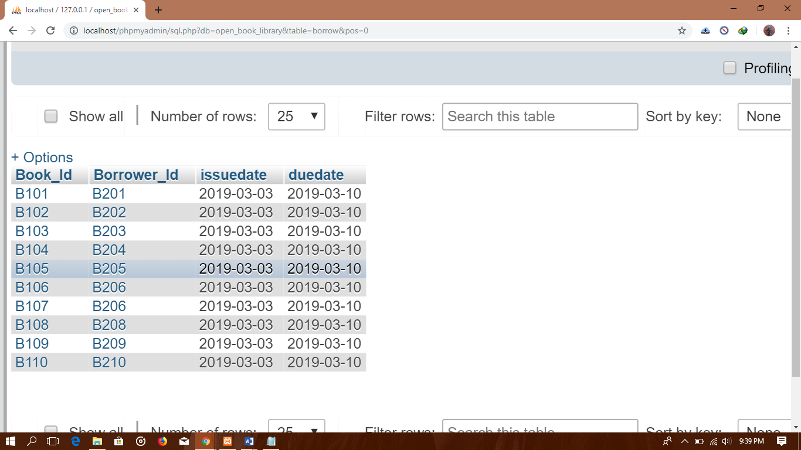

Updating the book code ‘B101’ to name ‘Introduction to Database’

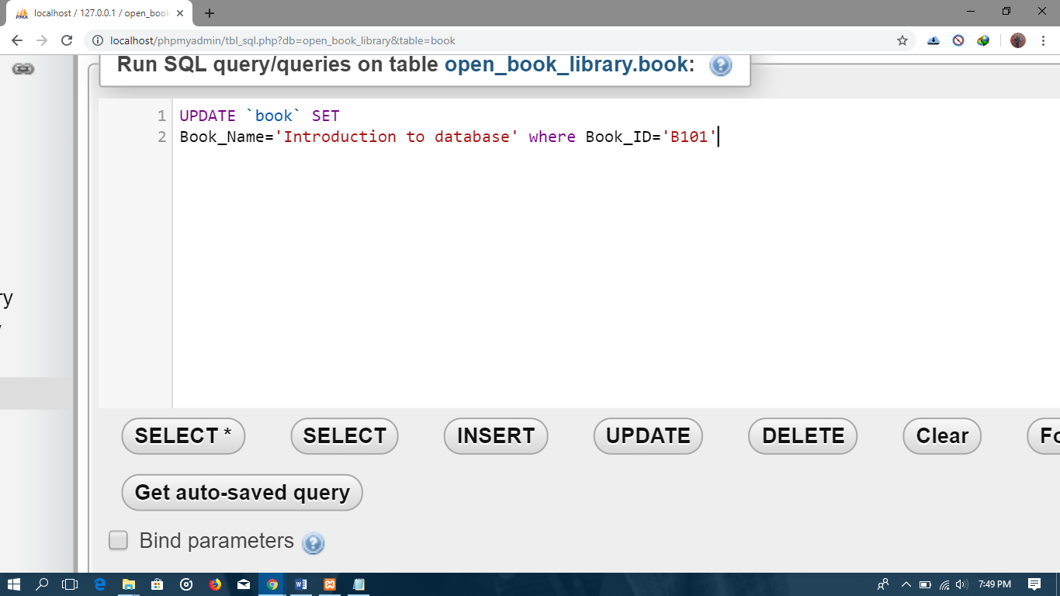

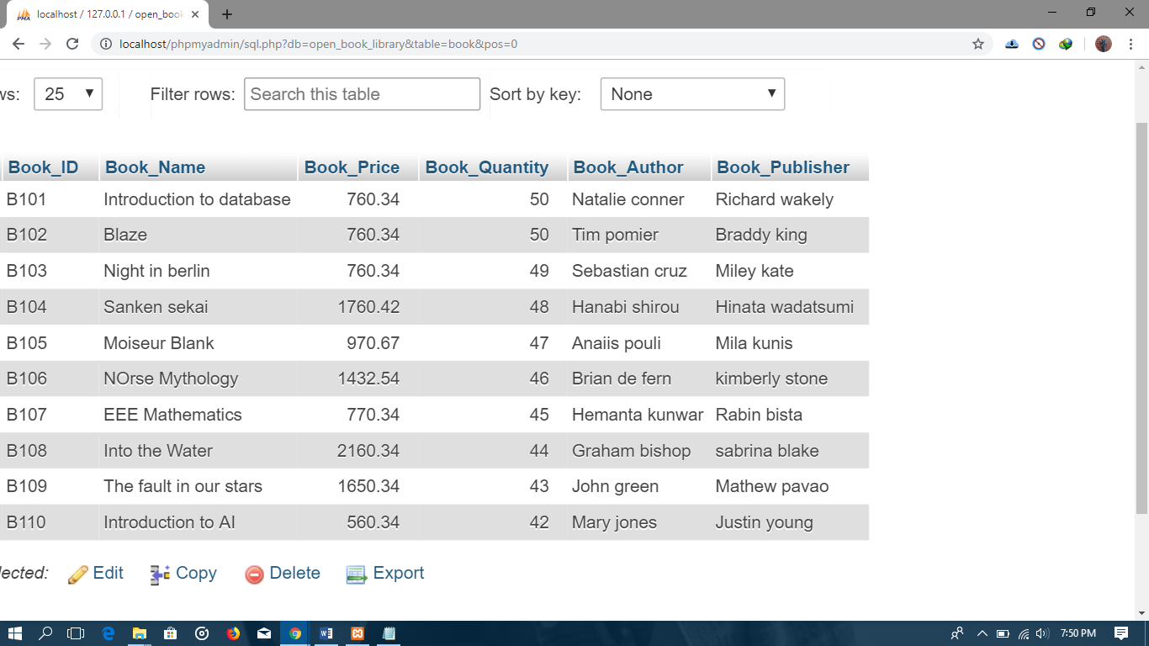

Delete book with code ‘B207’
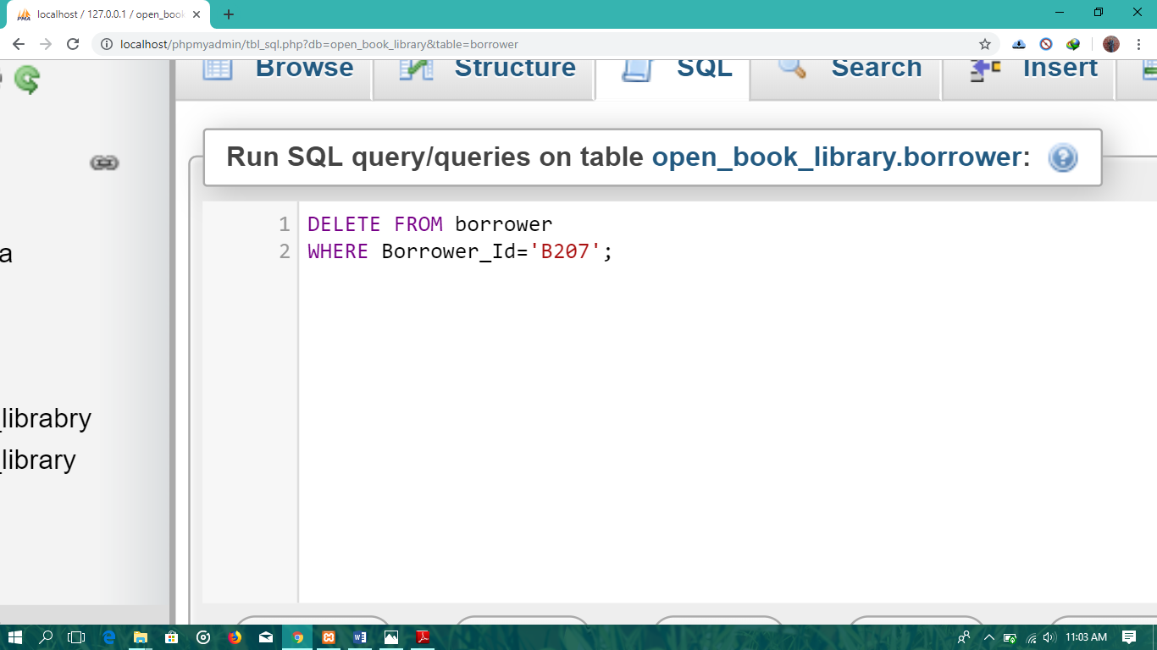

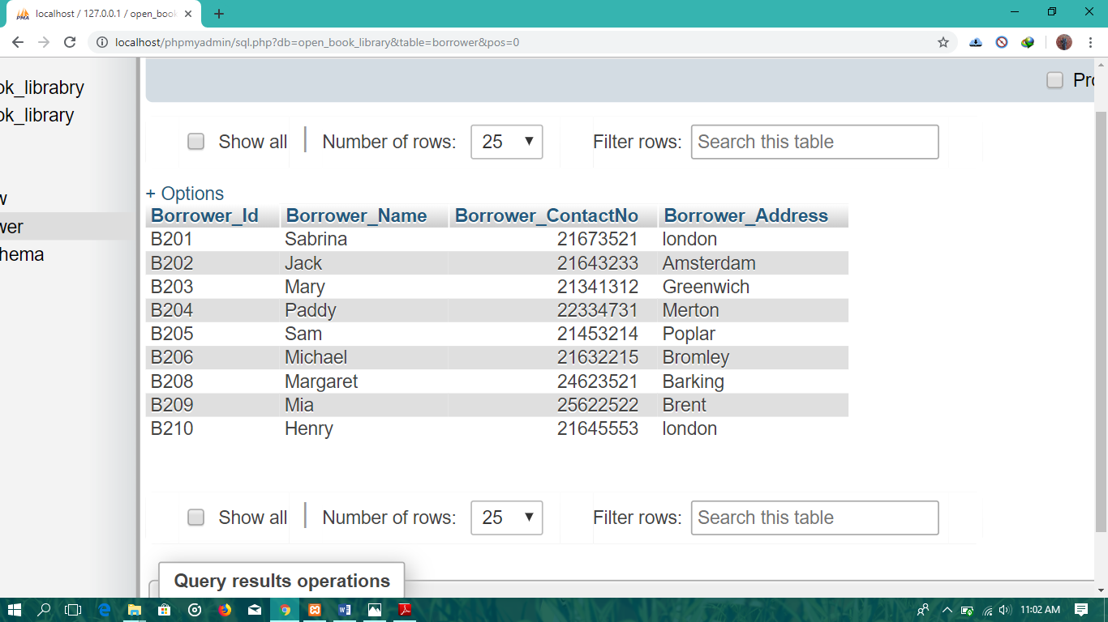

Displaying the name of the Books in Alphabet order

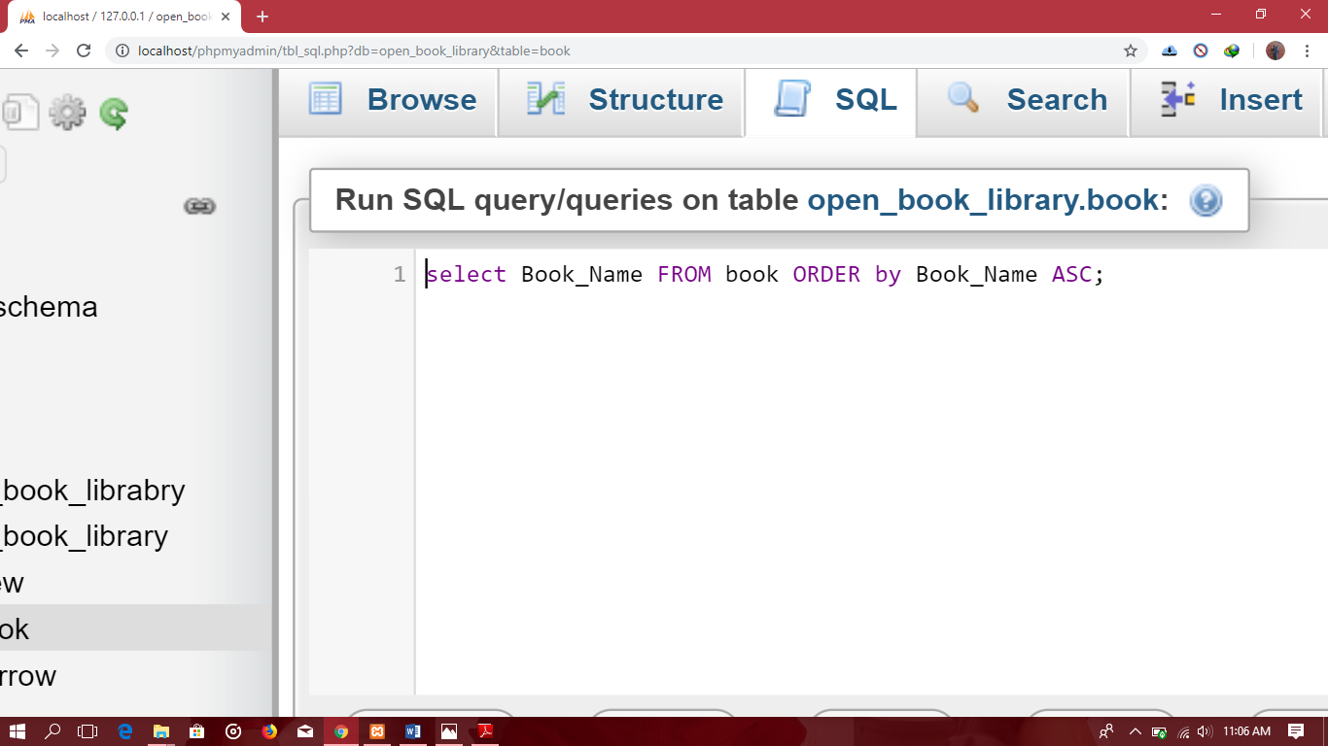

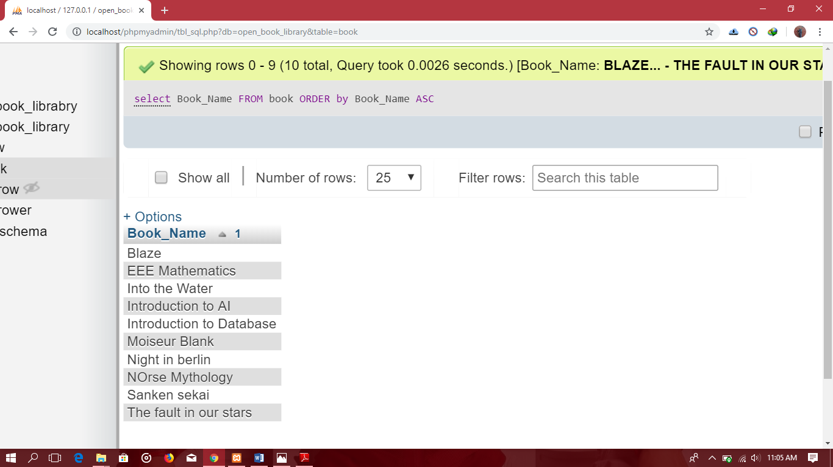

Displaying the code, Name and Quantity of books in descending order

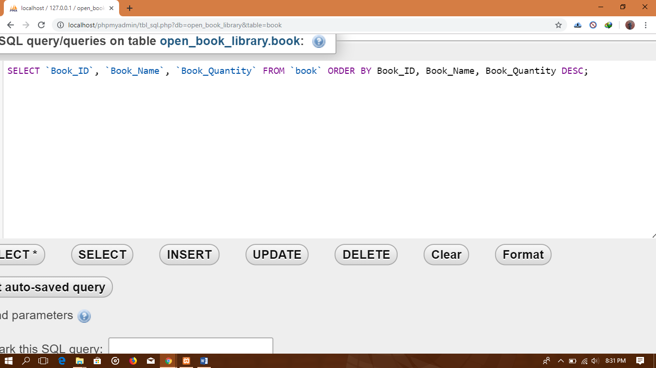

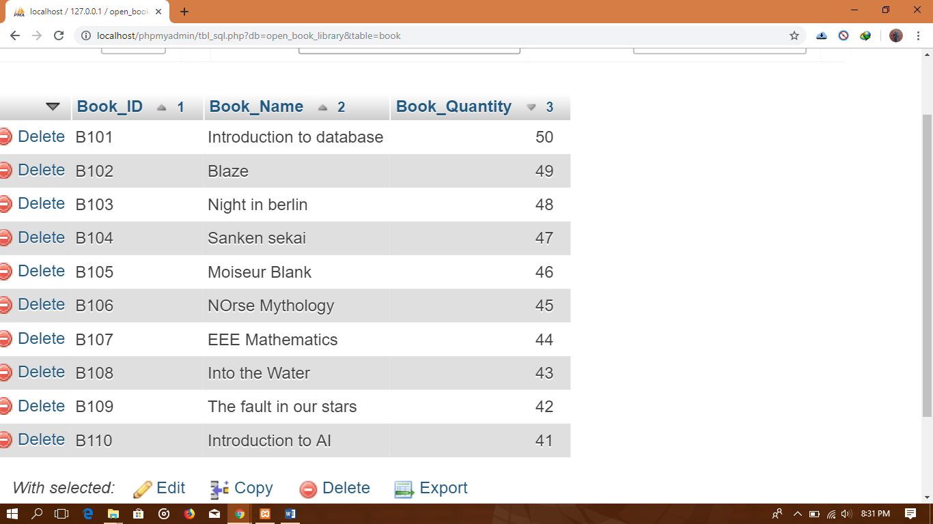

Listing the name of Book shaving unit price above 1000 borrowed by reader B204.
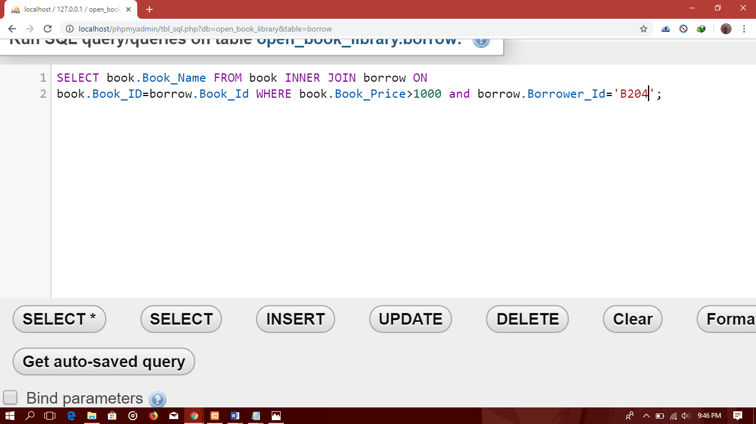

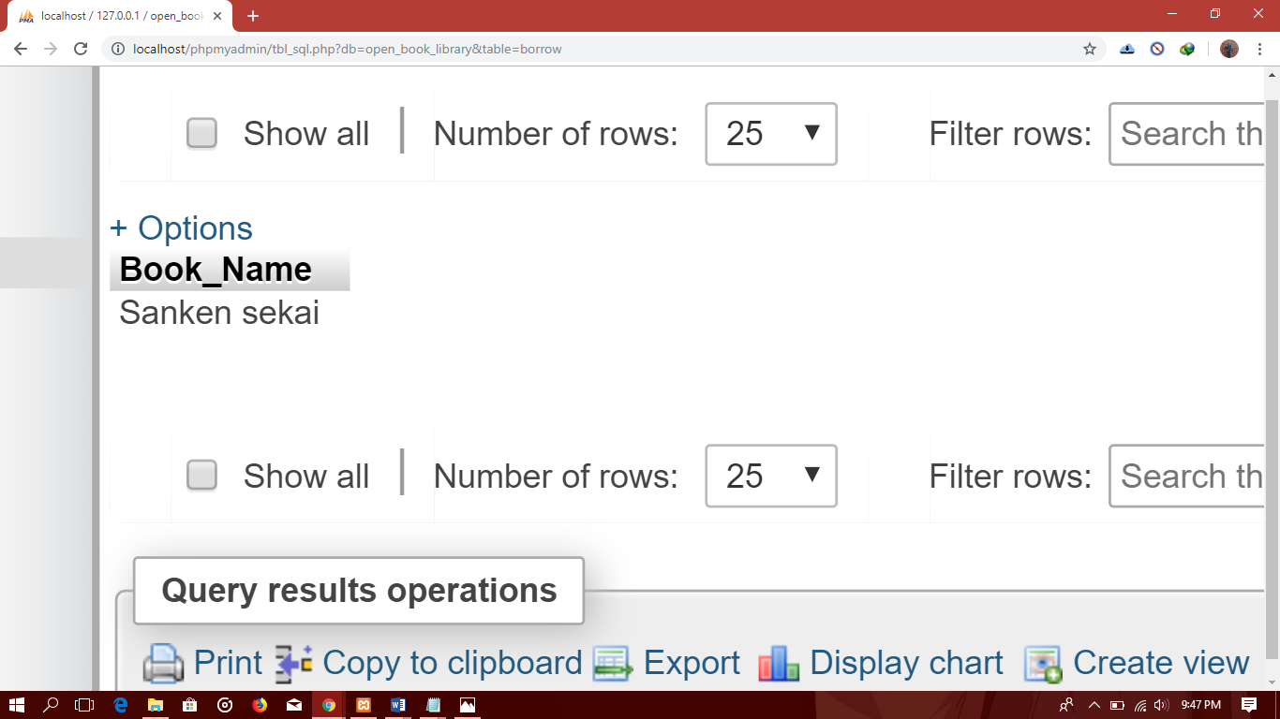

Conclusion
The main motive to engage students in understanding Database, SQL query is successfully accomplished with the help of this coursework. Working with Xampp, SQL queries and testing helped to learn and practice database management very effectively. This coursework has helped students to become familiar with the entities, attributes while generating the ER diagram. Queries were clearly understood. The syntax and functions to create, update and insert attributes were properly understood. Using Xampp was interesting which helped in maintaining quite good level of interest in doing the coursework.
In general, problems are faced during completion of any given task. Likewise, different problems were faced during the preparation as well as completion of the course work. First of all, problems were faced during making ER diagram and were resolved with the help of Module Tutor. Secondly, problems were faced about structure of the SQL query and finally the problems faced were about the process of report writing.
The coursework not only helped in understanding the database management system but also helped in self-evaluation while facing problems and looking for the solutions. Report made students involved in SQL queries which helped to gain extra skills, knowledge and developed problem solving skills.

Bibliography
Guru99, 2019. What is SQL Server?Introduction, History, Editions, Instances. [Online]
Available at: https://www.guru99.com/sql-server-introduction.html
iDatalabs, 2019. Companies using Microsoft SQL Server. [Online]
Available at: https://idatalabs.com/tech/products/microsoft-sql-server
Kofler, M., 2019. What are the top MySQL features?. [Online]
Available at: https://searchitchannel.techtarget.com/feature/What-are-the-top-MySQL-features-What-is-MySQL
Oracle, 2019. Introduction to Oracle Database. [Online]
Available at: https://docs.oracle.com/cd/B19306_01/server.102/b14220/intro.htm
Oracle, 2019. Key Database Features. [Online]
Available at: https://www.oracle.com/technetwork/database/options/index.html

